2D 3-axis CNC Pen Plotter

For this project we decided to build a physical one. Making an CNC Pen Plotter who can write and draw anything you would like.
The project is based on Arduino and includes GRBL code. It contains three hobby stepping motors and 3D parts that provide movement in three axes. I start the first step of the project by assembling the 3D parts and stepping motors that make up the main structure of the project. 3D models are printed in medium quality without support and the required screw types vary, you can use the compatible size in your workshop.
The circuit part of the project requires one Arduino Nano and three stepper motor drivers. You can build the project on a breadboard by following the shared circuit diagram,

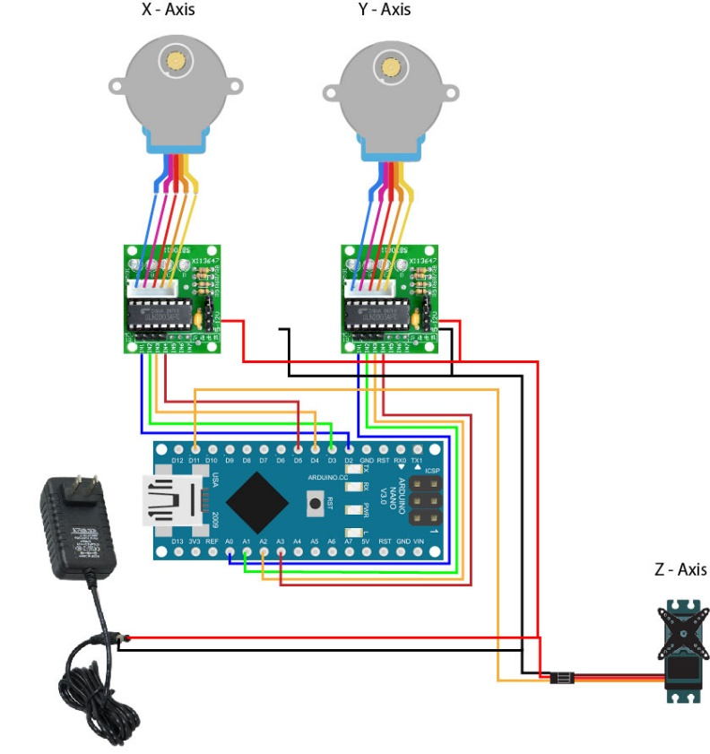

Using the lab 3D printer we managed to print the needed parts and the axes to make the movement possible.

